 | 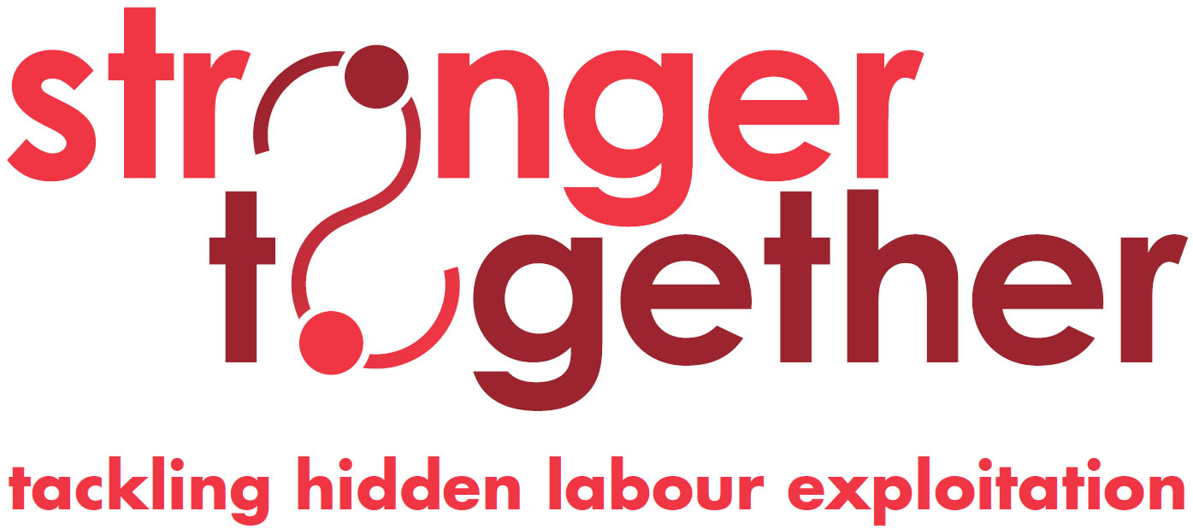
Preventing Hidden Labour Exploitation & Tackling Modern Slavery Policy

Premier Recruitment Group Limited commits to developing and adopting a proactive approach to tackling hidden labour exploitation & tackling modern slavery
Hidden labour exploitation is exploitation of job applicants or workers by third party individuals or gangs other than the employer or labour provider including rogue individuals working within these businesses but without the knowledge of management. It includes forced labour and human trafficking for labour exploitation; payment for work-finding services and work-related exploitation such as forced use of accommodation. It is understood that it is often well hidden by the perpetrators with victims, if they perceive of themselves as such, reluctant to come forward.
Coverage
This policy applies to all sites supplied.
Responsibility

The directors of Premier Recruitment Group Limited have overall responsibility for this policy.
Every member of Premier's management team have a responsibility to identify, tackle and prevent exploitation

Policy Commitments

Premier Recruitment Group Limited shall:

- Designate appropriate managers to attend “Tackling Hidden Labour Exploitation” training and to have responsibility for developing and operating company procedures relevant to this issue.
- Accept that job finding fees are a business cost, and will not allow these to be paid by job applicants. The Company will not use any individual or organisation to source and supply workers without confirming that workers are not being charged a work finding fee.
- Restrict the payment of workers’ wages to others bank accounts.
- Ensure that all staff responsible for directly recruiting workers are aware of issues around third party labour exploitation and signs to look for and have signed appropriate Compliance Principles.
- Ensure that labour sourcing, recruitment and worker placement processes are under the control of trusted and competent staff members.
- Adopt a proactive approach to reporting suspicions of hidden worker exploitation to the Gangmasters Licensing Authority and police.
- Provide information on tackling “Hidden Labour Exploitation” to our workforce through in a variety of formats such as workplace posters, worker leaflets, induction, other training.
- Encourage workers to report cases of hidden third party labour exploitation, provide the means to do so and investigate and act on reports appropriately.
- Positively encourage and support employees and agency workers to report such exploitation which may be occurring within their communities by providing them with the information on how and who to report abuse to.
- Encourage other labour providers and organisations in the labour supply chain to adopt policies and procedures consistent with the above.

Premier Recruitment Group Limited has a zero tolerance approach to modern slavery and is committed to acting ethically and with integrity and transparency in all of its business dealings and relationships and to implementing and enforcing effective systems and controls to ensure that modern slavery and human trafficking are not taking place anywhere within either its own business or in any of its supply chains.

